Lab 8

Exercise

1.

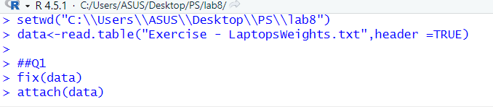

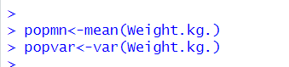

2.

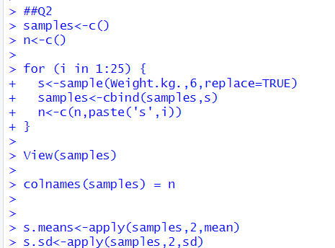

3.

